Edward Welborn

Interfaces and Usability

DEV2318-O

C20190801

The Concept:

A new world of warcraft armory program, that blizzard had a few years ago. They do have a new companion application, but it does not do the armor upgrades like the old application does.

I would love to be able to show a character, click the gear, and show possible upgrades and how they can be achieved like the old program does

This application will be written for tablet and phones for iOS and android.

The four major screens would be a login, the character screen with dropdowns to pick character and server, the armor upgrade screen when you click a piece of armor from the character screen it would pop up with upgrades and how to obtain them, perhaps and auction screen where you can buy and sell, a guild screen, with chat and online guildies.

There are currently no applications like this. The new world of warcraft companion application just shows the armor you are wearing without the upgrade possibilities.

Below are screenshots from the old world of warcraft armory, there are no other games that have this capability at this time, but if the user had the API and the company gave them read only access to the database, then more applications could be written like this for other games.

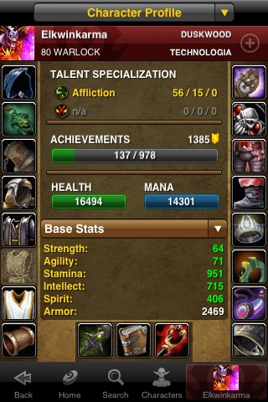

This screenshot was from the website that was associated with the wow armory, it is no longer working either.